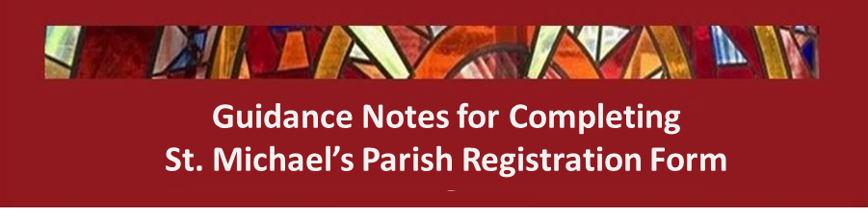

Introduction
Thank-you for deciding to register with St. Michael’s Parish. The information gathered will be used over the coming years not just for the administration of the parish but also in planning activities and services and identifying Parishioners’ needs and volunteers who make up the largest part of our Parish team.

Online or Paper
Since the start of the Pandemic the Parish has moved increasingly towards online communications through emails, Facebook and the Parish Website, but we realise that not everyone has access or ability to correspond with us this way. So, we are offering both online and paper Registration forms.
In either case, the content of the form is the same. The big advantage for the Parish office is that if you are able to enter your data online, then it is automatically captured for us and for this you have our eternal gratitude! We can also automatically give you a record of what you have entered.

The Parish Registration Form – what information is being requested?
Our registration form starts with a general statement on GDPR.
The General Data Protection Regulation is a regulation made in EU law on data protection and privacy. Its primary aim is to enhance individuals' control and rights over their personal data and contains provisions and requirements related to the processing of personal data of individuals. The GDPR became law in the UK on 25 May 2018.
At the beginning of the form is a section providing a summary of your rights under GDPR. It also explains that as part of the Diocese of Arundel and Brighton, we are bound by their overall policies and provides a link to these policies on the diocesan website.
By completing the Parish Registration form you are agreeing to allow us to hold your data under the terms of these policies.

The rest of the form is divided into 5 sections –

1. The Household
The household section describes your household or family group, living together at a single address and with a primary contact person and phone number.

2. Family Members
You will need to enter one record for each family member in your household (including the primary contact) detailing Name, address, date of birth and email / mobile (optional) phone numbers.
The form also asks if the family member is a Catholic and, if so, which sacraments they have received.
We realise that you may have non-Catholic family members and it is up to you whether you include them on the form, but we would prefer that you do. Many non-Catholics participate in Parish activities and attend services and are, of course, very welcome.
Finally, for younger members we also ask which school they are attending.
3. Parish Support
This short section is focused on identifying particular needs for any member of your household. Perhaps to do with infirmity, pastoral care or mobility and access to the church.

4. Financial Support for the Parish
There is a single question to determine your preferred methods of giving to the Parish.

5. Church Ministries
Like all parishes, St. Michael’s is heavily indebted to parishioners who support its daily activities as volunteers. The scope of ministries is very broad, ranging from Liturgical and sacramental programmes to Administration, Finance, Working with Care and Outreach groups and even communications and IT.

Following the pandemic, we are keen to re-establish our lists of volunteers. So if you are already participating in one or more of these ministries or are interested in doing so, please tick the appropriate boxes.

Completing the Online form

The online form should be simple to use and has two advantages for us. Firstly, it avoids us having to enter your data and secondly, it gathers and presents your data to us. So please give it a try if you can.

Here are some suggestions for making it even easier –

- Be prepared! While testing the online form, we estimated that it takes 2-3 minutes per family member to enter the data once the information has been gathered.
- Paper Template You might want to print and use the paper form as a template. The questions are the same and will appear in the same order. It will also provide you with a record of what you entered.
- Forward and back buttons There are buttons on the electronic form that allow you to go back to previous sections and check / edit what you have entered. If you go back to a previous section, the data that you entered will be kept and can be edited by you.
- Printed copy At the end of the online form you will be asked if you want to print a copy or download your responses in the form of a PDF file.
- Questions If you have any questions relating to registration, please contact us on smichaeloffice@gmail.com and we will respond as quickly as possible.

Completing the Paper form
If you can’t complete an online form, please complete a paper one. You can either pick one up from the Parish Office or download it from the registration page on the parish website. When you have completed the form, please return it to the Parish Office.

